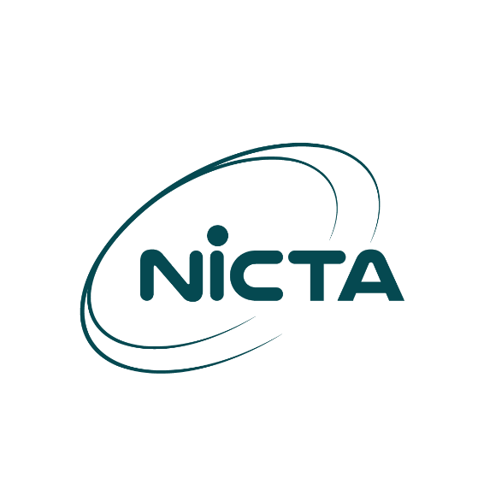

Form COP100
Application for Certificate of Proficiency

- GENERAL DETAILS OF APPLICANT
- Name of Applicant
First Name  Click or tap here to enter text. |  |  | Last Name  Click or tap here to enter text.
- Address
PO Box  Click or tap here to enter text. |  | PO Branch  Click or tap here to enter text. |  | Postcode  Click or tap here to enter text.
Province
Click or tap here to enter text.
- Telephone  +675- | - Mobile  +675- |  | - Facsimile  * |  | - Email  *

- PARTICULAR DETAILS OF APPLICANT
- Date of Birth:  * | - Birth Origin:  * | - Height:  *
- Color of Eyes:  * | - Color of Hair:  * | - Skin Complexion:  *

- CERTIFICATION
Select;
☐ New Certificate: |  | ☐ Re-validation:  Certificate No: * |  | ☐ Replacement:  Certificate No: *
Select;
☐ GMDSS - General |  |  | ☐ GMDSS - Restricted
☐ MROCP |  |  | ☐ Amateur
☐ Other
Specify: Click or tap here to enter text.
- Location at which Examination is required:
☐ NICTA HQ | ☐ Vessel:  Name of Vessel: Click or tap here to enter text.  Location of Moored Vessel: Click or tap here to enter text.
☐ Other: Click or tap here to enter text.

- DECLARATION
- I/We hereby declare that the information and particulars given by me/us in this form and in the documents submitted are to the best of my/our knowledge true, correct and complete. I/We understand that any untrue, incorrect and/or incomplete information in this form and the documents submitted may lead to rejection of the application.

Signature:
Full Name of Signatory:  (in block letters): | Click or tap here to enter text.
Date: | Click or tap here to enter text.

