Form COP100
Application for Certificate of Proficiency

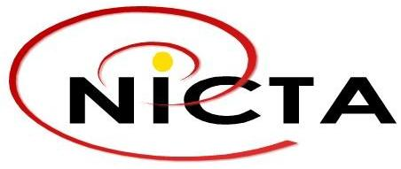

- GENERAL DETAILS OF APPLICANT
- Name of Applicant
First Name |  |  | Last Name
- Address
PO Box |  | PO Branch |  | Postcode
Province

- Telephone | - Mobile |  | - Facsimile |  | - Email

- PARTICULAR DETAILS OF APPLICANT
- Date of Birth: | - Birth Origin: | - Height:
- Color of Eyes: | - Color of Hair: | - Skin Complexion:

- CERTIFICATION
Select;
New Certificate: |  | Re-validation:  Certificate No: |  | Replacement:  Certificate No:
Select;
GMDSS - General |  |  | GMDSS - Restricted
MROCP |  |  | Amateur
Other
Specify:
- Location at which Examination is required:
NICTA HQ | Vessel:  Name of Vessel:  Location of Moored Vessel:
Other:

- DECLARATION
- I/We hereby declare that the information and particulars given by me/us in this form and in the documents submitted are to the best of my/our knowledge true, correct and complete. I/We understand that any untrue, incorrect and/or incomplete information in this form and the documents submitted may lead to rejection of the application.

Signature:
Full Name of Signatory:
(in block letters):
Date:

