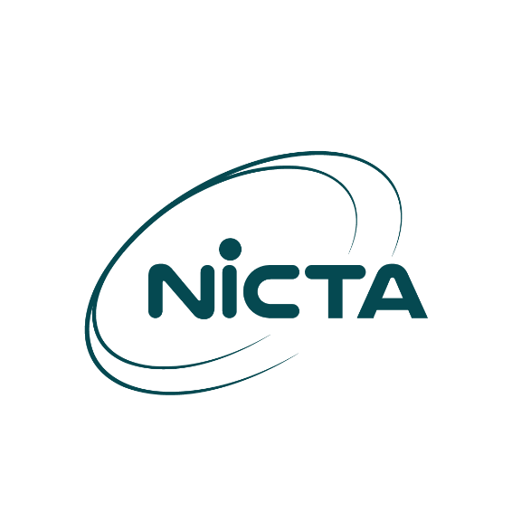

- Content
Application for Operator Licence
Form OP200

GENERAL INFORMATION
- DETAILS OF APPLICANT
- Name of Applicant
Title  * | First Name  * |  |  |  | Last Name  *
- Name of Contact Person (if different from Applicant)
Title  * | First Name  * |  |  |  | Last Name  *
- Existing Licence No. (if applicable)
*
- Name under which Licence is to be issued
*
- Address
PO Box  * |  |  | PO Branch  * |  |  | Postcode  *
Province
*
- Telephone  * |  | - Mobile  * |  | - Facsimile  * |  |  | - Email  *

- COMPANY INFORMATION
- If the applicant is a company incorporated in Papua New Guinea, it is required to submit a copy of its Certificate of Incorporation, Company constitution, Company Registration Number and attach a copy of the current company extract from the Companies Office. If the applicant is required to hold a certificate under Sections 29 or 36E of the Investment Promotion Act 1992, attach a copy of a current certificate.
- Provide the latest annual financial statements audited by a registered company auditor;
- Provide the latest annual report;
- Details of shareholding structure; direct or indirect. The applicant is required to provide document showing the authorized, issued and paid-up share capital and the current share holding structure of the company. The applicant is required to submit a copy of the documents that it filed to the IPA.
- If the director(s) of the applicant company is/are also the director(s) of other companies which currently hold or previously held any licences issued by the NICTA, please provide a list of such licences, licence numbers and licensees’ names in relation to each director. If not applicable, please insert “NIL”.
- Provide a copy of any agreement between the Port Moresby stock exchange and the applicant or any related company of the applicant;
- All other necessary information as required under Section 10 of the National ICT Regulations 2010

- EXPERIENCE IN BROADCASTING
- The applicant must have the capability of running the proposed broadcasting network to the satisfaction of NICTA. This includes the expertise required for the operation of the proposed network. Previous experience in operating broadcasting network in Papua New Guinea or overseas will be considered. The applicant may list out his/her experience in broadcasting for NICTA’s consideration.

- TECHNICAL SUPPORT DETAILS
- Description of the technical support facilities in Papua New Guinea.
- Description of the technical personnel responsible for day-to-day operation and maintenance of the support facilities
- Description of the details of system maintenance schedule/procedure

- INDIVIDUAL CONTENT LICENCE
- Provide description of content to be provided. The licensee is not restricted to providing content not selected below. However, NICTA must to be notified should additional content and service areas are to be provided and covered in the future
 | National | Provincial | District
☐ Free TV Broadcast | ☐ | ☐ | ☐
☐ Subscription TV Broadcast | ☐ | ☐ | ☐
☐ Public Cellular Services | ☐ | ☐ | ☐
☐ Radio Broadcast | ☐ | ☐ | ☐

DECLARATION
- I/We hereby declare that the information and particulars given by me/us in this form and in the documents submitted are to the best of my/our knowledge true, correct and complete. I/We understand that any untrue, incorrect and/or incomplete information in this form and the documents submitted may lead to rejection of the application.

Signature | Click or tap here to enter text.
Full Name of Signatory  (in block letters) | Click or tap here to enter text.
Position held: | Click or tap here to enter text.
Date: | Click or tap here to enter text.

