Form OP300
Registration for Operator Class Licence

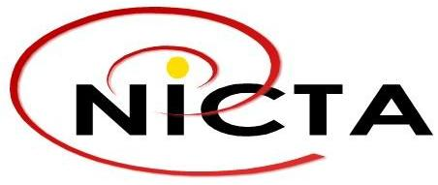

GENERAL INFORMATION
- DETAILS OF APPLICANT
- Name of Applicant
Title | First Name |  |  |  | Last Name
- Name of Contact Person (if different from Applicant)
Title | First Name |  |  |  | Last Name
- Name under which Licence is to be issued

- Address
P.O Box |  |  | P.O Branch |  |  | Postcode
Province

- Telephone |  | - Mobile |  | - Facsimile |  |  | - Email

- INDIVIDUAL/COMPANY INFORMATION
- If applicant is an individual, attach a copy of certificate of birth and/or other evidence showing PNG citizenship. (Evidence may include a copy of registration certificate on voting rolls for PNG, a certificate of citizenship if applicable, or a certificate of birth showing birthplace as a place in PNG.)
- If the applicant is a company, provide the company registration number and relevant documents/certificates under the Investment Promotion Act 1992
- If the applicant is a company and a foreign enterprise, provide copies of the relevant certificates under the Investment Promotion Ac, 1992, authorizing foreign investment in PNG

- TYPE OF OPERATOR CLASS LICENCE
- Network Operator Class Licence
Facility rights: in relation to private use of all facilities
Network services: in relation to the supply for private use of all network services
- Applications Operator Class Licence
Applications service: in relation to private use of one or more of PSTN telephony, public switched data and public cellular services as a community service within a closed user group
Applications service: in relation to private use of one or more of internet access, IP telephony, directory, messaging, audiotext hosting, public payphone or other non-exempt applications services
- Content Operator class Licence
Content service: in relation to TV or radio broadcast services as a narrowcasting service within a closed user group
Content service: in relation to TV or radio broadcast services as a community service within a closed user group

- DETAILS OF OPERATOR CLASS LICENCE
- Provide a description of the intended use of the facilities or services
- Provide a description of the facilities, network service, applications service or content service and areas of coverage and types of technology to be used
- Provide operating procedures including a network topology, details of equipment to be used, connectivity to be obtained
- Provide details of any ICT individual licence or operator class licence registration held by the applicant or by any related company at the date of this application
- Provide any other information that would be relevant for NICTA’s assessment of this application for registration under a operator class licence

DECLARATION
- I/We hereby declare that the information and particulars given by me/us in this form and in the documents submitted are to the best of my/our knowledge true, correct and complete. I/We understand that any untrue, incorrect and/or incomplete information in this form and the documents submitted may lead to rejection of the application.

Signature
Full Name of Signatory
(in block letters)
Position held:
Date:

Attachment A: Checklist for Registration

- Duly completed Form OP300
- A registration fee of K500.00 + GST
- Such additional information or document as may be requested by NICTA

